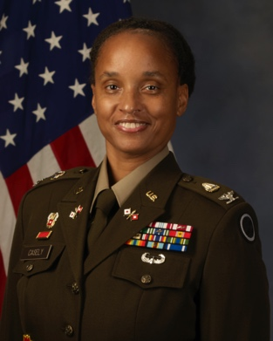
COLONEL ELIZABETH (LIZ) A. CASELY
I Corps Assistant Chief of Staff, G6

COL Elizabeth (Liz) Casely is the I Corps Assistant Chief of Staff, G6, located at Joint Base Lewis-McChord (JBLM) where she leads a directorate that plans, engineers and delivers networked services and capabilities to the warfighter. Her primary focus is the foundational operational and tactical network architecture that supports multi-domain, multi-layer and multi-dimensional operations in the Indo-Pacific region. Additionally, she serves as the I Corps Commander’s principal advisor for all network modernization activities including diverse assured transport, persistent information environment architecture such as cloud computing, and data operations. Liz directs two approaches for modernization: (1) innovate with current solutions used in different ways; and (2) experiment with new technology to test operational validity and inform future design goals.

Liz entered military service through the United States Military Academy at West Point where she received a commission in the United States Army Signal Corps. Her career includes assignments at Fort Bliss, Texas, Fort Detrick, Maryland, Hawaii, Korea, Germany, the National Capital Region (NCR) and JBLM. These assignments include two deployments with the 25th Infantry Division, where she led the planning and managing of communications networks for military units in Northern Iraq and Central Iraq.

Upon Liz’s return from Iraq in 2011, she transitioned to the United States Indo-Pacific Command where she assisted in the establishment the USINDOPACOM Joint Cyber Center. Liz then commanded the 86th Expeditionary Signal Battalion in Fort Bliss, Texas. Following battalion command, Liz pursued a programming and budgeting focus as the mission command and defensive cyber program analyst in the Army G8 where she was responsible for fusing acquisitions, force management, and fiscal resources in a way that balanced the Army’s current readiness with future modernization.
Liz graduated from the Army War College in 2019, where she conducted a focused study on innovation, organizational structure, culture, and change. Subsequently, she served as the Chief of Staff for the Army Futures Command’s Network Cross Functional Team (NCFT) at Aberdeen Proving Ground, Maryland where she led the integration and synchronization of the cross-functional team and drove integrated network modernization planning efforts to inform strategic planning, programming, resourcing, and acquisition decisions.
Liz serves as President of the Armed Forces Communications and Electronics Association (AFCEA), Pacific Northwest (PNW) Chapter. This organization focuses on enabling joint warfighting capabilities in the Pacific by integrating military, government, industry and academia to align current technology with strategy. Liz also holds a Master of Business Administration degree from Webster University and a Master of Strategic Studies degree from the Army War College.

